Monthly Reports

Double click on QV (Quick Viewer) and click; “All Entries by Date Range”

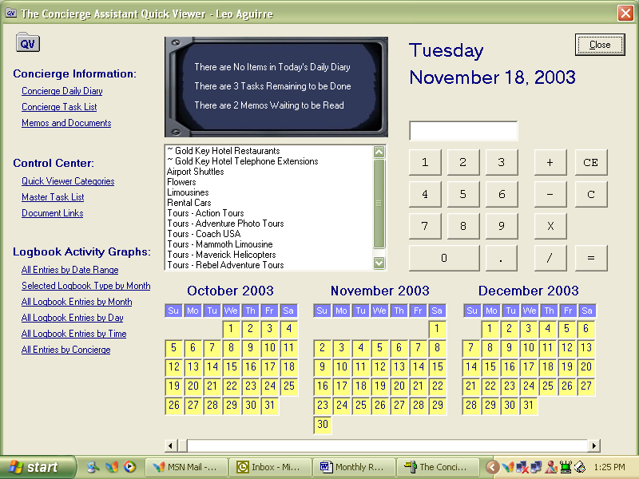

Select the desired date range and indicate the program if you want to see the archived or current information,

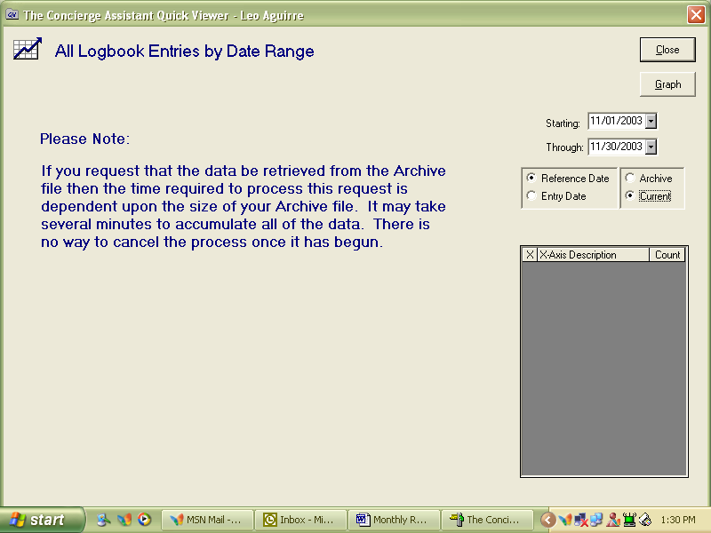

Click Graph and you will see your logbook activity for the desired date range

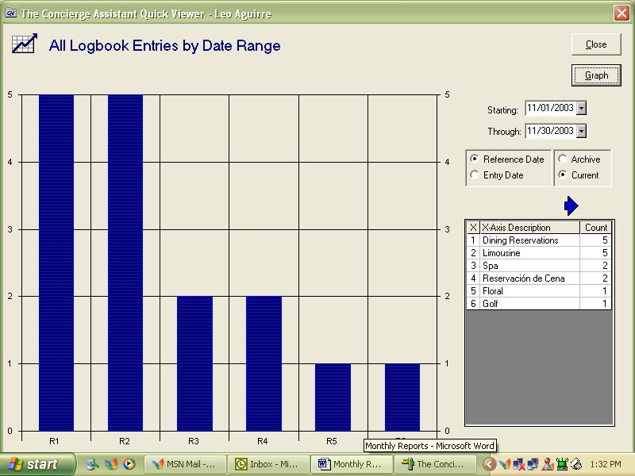

To print the report hit F4 key and you will see the print preview screen, click the printer button and you will print your report.

